

CSC 1300 LAB 6 PURPLE

**Spring 2023, February 27, 2023 through March 3, 2023**

# Monster Data Program

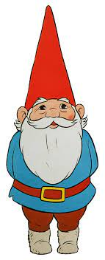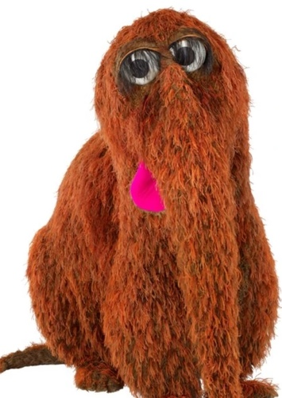

## Concepts

* Input & output files
* Functions

## Description

You want to develop a way for users to store and print one monster’s information in a program.

## Instructions

* In your **CSC1300LAB** folder, create a **LAB6Purple_yourTTUusername** folder and inside that folder, create a source file named **lab6.cpp**.
* Make sure you put a comment block at the top of your source file with the filename, author, date, and purpose. Also make sure there are appropriate comments throughout your program. You should have a comment above each function saying the function name & purpose of the function.
* Test your program with both sample outputs provided in this document..

**Main Function**

* Write a loop that will allow the user to continue to run the program again until they select to “Save & Quit Program” from a menu of choices.
* Inside the loop, call the **displayMenuGetChoice()** function, which should return the user’s choice and you will store that value in an integer variable.
* Based off the user’s choice, use a switch statement to execute the proper action.
* If the user selected 1, then let the user enter monster data from the screen. The user will be able to enter the monster’s name, monster’s age in years (integer), monster’s height in feet (double), monster’s weight in pounds (double), the food the monster prefers, and a fun fact about the monster.
* If the user selected 2, then your program should open the “monsterData.txt” file and then read each piece of data from the file and store the data in variables. Then, close the file. Last, print a confirmation stating the monster’s name and say that the monster has been read from the file.
* If the user selected 3, then your program should print the monster’s data neatly to the screen. Refer to sample output to view the suggested format.
* If the user selects 4 then the program will exit the loop and then will call the **printToFile()** function, sending the monsterName, age, height, weight, monsterFood, and funFact to this function.
* Then, the program should print “GOODBYE!” to the screen. (this should be printed in the main function, not the printToFile function)

**displayMenuGetChoice() Function**

This function will do the following:

* Prints a menu of choices (refer to sample output) and asks the user to choose 1-4.
* Reads in the user’s choice
* Validates that the user’s choice is within the range of 1 through 4 inclusively. If not, then it should force the user to enter again until valid choice is selected.
* Returns the user’s choice from this function, which is an integer.

**printToFile() Function**

This function will do the following:

* Accepts six arguments containing monster data
* Opens an output file called “monsterData.txt”.
* Prints the monster data to the file – one piece of information per line.
* Closes the file.
* Prints a confirmation that the monster (print monster’s name) has been saved to monsterData.txt. (this should be printed in the printToFile function, not the main function)

## sample output & Text Files

### Sample Output 1

All user input is highlighted in **yellow**.

**1. Enter a Monster's Data from Screen**

**2. Read a Monster's Data from File**

**3. Print the Monster's Data to screen**

**4. Save & Quit Program**

**CHOOSE 1-4: 2**

**The monsterData.txt file does not exist.**

**1. Enter a Monster's Data from Screen**

**2. Read a Monster's Data from File**

**3. Print the Monster's Data to screen**

**4. Save & Quit Program**

**CHOOSE 1-4: 1**

**Monster Name: David the Gnome**

**David the Gnome's age (years): 175**

**David the Gnome's height (feet): 3.5**

**David the Gnome's weight (pounds): 46.5**

**Food that David the Gnome prefers: nuts, mushrooms, peas, beans, applesauce, fruit, berries, tubers, spices, and preserves**

**Fun fact about David the Gnome: David is banned from the Middle Tennessee Horticultural Society Rose Show due to poking attendees with rose thorns last year.**

**1. Enter a Monster's Data from Screen**

**2. Read a Monster's Data from File**

**3. Print the Monster's Data to screen**

**4. Save & Quit Program**

**CHOOSE 1-4: 3**

**MONSTER NAME: David the Gnome**

**AGE (YEARS): 175**

**HEIGHT (FEET): 3.5**

**WEIGHT (POUNDS): 46.5**

**FOOD IT EATS:**

**nuts, mushrooms, peas, beans, applesauce, fruit, berries, tubers, spices, and preserves**

**FUN FACT:**

**David is banned from the Middle Tennessee Horticultural Society Rose Show due to poking attendees with rose thorns last year.**

**1. Enter a Monster's Data from Screen**

**2. Read a Monster's Data from File**

**3. Print the Monster's Data to screen**

**4. Save & Quit Program**

**CHOOSE 1-4: 9**

**Invalid input. CHOOSE 1-4: 4**

**The monster, David the Gnome, has been saved to the monsterData.txt file.**

**GOODBYE!**

### monsterData.txt AFTER RUNNING SAMPLE OUTPUT 1

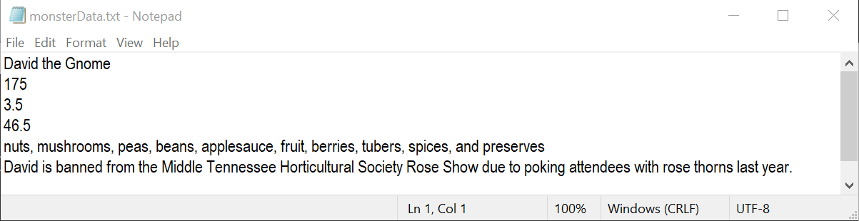

### Sample Output 2

**1. Enter a Monster's Data from Screen**

**2. Read a Monster's Data from File**

**3. Print the Monster's Data to screen**

**4. Save & Quit Program**

**CHOOSE 1-4: 2**

**David the Gnome has been read from the file.**

**1. Enter a Monster's Data from Screen**

**2. Read a Monster's Data from File**

**3. Print the Monster's Data to screen**

**4. Save & Quit Program**

**CHOOSE 1-4: 3**

**MONSTER NAME: David the Gnome**

**AGE (YEARS): 175**

**HEIGHT (FEET): 3.5**

**WEIGHT (POUNDS): 46.5**

**FOOD IT EATS:**

**nuts, mushrooms, peas, beans, applesauce, fruit, berries, tubers, spices, and preserves**

**FUN FACT:**

**David is banned from the Middle Tennessee Horticultural Society Rose Show due to poking attendees with rose thorns last year.**

**1. Enter a Monster's Data from Screen**

**2. Read a Monster's Data from File**

**3. Print the Monster's Data to screen**

**4. Save & Quit Program**

**CHOOSE 1-4: 6**

**Invalid input. CHOOSE 1-4: 1**

**Monster Name: Mr. Snuffleupagus**

**Mr. Snuffleupagus's age (years): 52**

**Mr. Snuffleupagus's height (feet): 7.5**

**Mr. Snuffleupagus's weight (pounds): 12756.4**

**Food that Mr. Snuffleupagus prefers: leaves, twigs, bark, roots, strawberries, apples, blackberries, bananas, and flowers**

**Fun fact about Mr. Snuffleupagus: All adults pretended Snuffy was invisible for the first 14 years of his life. It is not clear if this caused him any emotional harm.**

**1. Enter a Monster's Data from Screen**

**2. Read a Monster's Data from File**

**3. Print the Monster's Data to screen**

**4. Save & Quit Program**

**CHOOSE 1-4: 3**

**MONSTER NAME: Mr. Snuffleupagus**

**AGE (YEARS): 52**

**HEIGHT (FEET): 7.5**

**WEIGHT (POUNDS): 12756.4**

**FOOD IT EATS:**

**leaves, twigs, bark, roots, strawberries, apples, blackberries, bananas, and flowers**

**FUN FACT:**

**All adults pretended Snuffy was invisible for the first 14 years of his life. It is not clear if this caused him any emotional harm.**

**1. Enter a Monster's Data from Screen**

**2. Read a Monster's Data from File**

**3. Print the Monster's Data to screen**

**4. Save & Quit Program**

**CHOOSE 1-4: 4**

**The monster, Mr. Snuffleupagus, has been saved to the monsterData.txt file.**

**GOODBYE!**

### monsterData.txt AFTER RUNNING SAMPLE OUTPUT 2

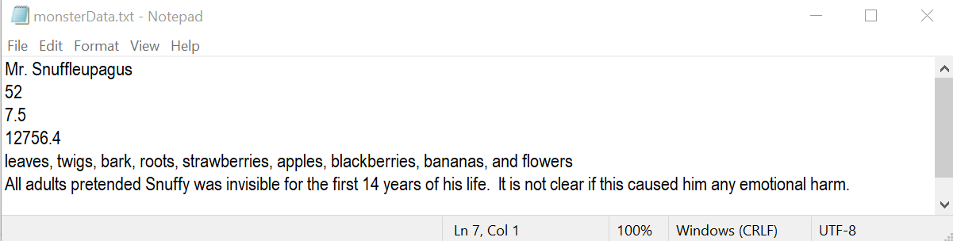

## What to Turn In

**Compress/zip** the **Lab6Purple_yourTTUusername** folder and upload it to the ilearn assignment folder named **Lab 6**.